Understand IT
Project number: 2010-1-NO1-LEO05-01839

WP08 - A generic business model

Design and deployment of a tool to implement a business plan (http://www.cenfim.pt/bpuit/intro.aspx)

Authored by the Portuguese Vitae Course Team:
José Fonseca – Cenfim
Rita Lima – CENFIM

WP08 final report

Design and deployment of a tool to implement a business plan

http://www.cenfim.pt/bpuit/intro.aspx

The main idea of this tool is to help the user on the definition of its own business plan to implement the vitae course.
Building on the results of the equivalent process carried out by the partners on this project, it's possible to define a set of options that will alert the user to the main aspects to be taken into account when defining the contents of each block.

As a result the user gets a kind of a "notes book" with a compilation of its options and reflexions, complemented by the description of similar cases, and a set of guidelines to turn them into a business plan.

The tool to implement a business plan was designed based on:
- The handbook written by Alexander Osterwalder & Yves Pigneur, Business Model Generation
- The partners experience on WP03 CC&D sessions related to the business plan
- The final document of WP03 – Business Plan

Activities
The web site required has been developed by following the activities:
  - Development of a Business model for the implementation of the Vitae courses in the four countries (WP3)
  - Evaluation of how well the model worked in each case (WP5 & WP7)
  - Development of the back office, to insert the business model data for each country (case studies), according to the Business Model Canvas blocks:
    - Customer Segments;
    - Value Proposition;
    - Channels;
    - Customer Relationships;
    - Revenue Streams;
    - Key Resources;
    - Key Activities;
    - Key Partnerships;
    - Cost Structure.

  - Data introduction
    - Global information (All partners together)
      - Block Names
      - Block Description
      - General text
    - Individual partner information for each block:
      - Options (Title and explanation)
      - Case study explanation
      - Attachments
  - Options consolidation (based on the options introduced by each partner)
  - Development of the end user interface with the following structure:
    - Login page
    - Introductory notes
    - Business model generation
      - Introduction of user options and notes for each block
    - Results - an online book with:
      - User’s answers and notes for each block
      - Case studies information, based on the level of similarity to each one in each block
      - Statistics showing the global similarity between the user case and the case studies
      - Access to the case studies business models, based on the global level of similarity
    - Business plan
      - Guideline to help users to convert the result achieved before into a business Plan organized by:
        - Business Idea
        - Personal Information
        - Product/Service
        - Market
        - Marketing and Sales activities
        - Budget and economy
        - The need for Capital an Financing
        - Course organization and administration

Login Process
Everyone, with a valid code can use this tool.  To get a Code:  - The user must introduce the Company or User Name and a valid Email address;  - The code will appear on the screen and is sent to the email address | 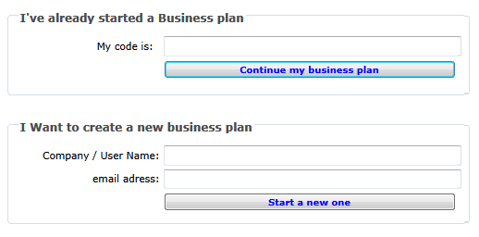
If the user already have started business model, can always return to it through the introduction of the related code.

User Interface
Introduction page
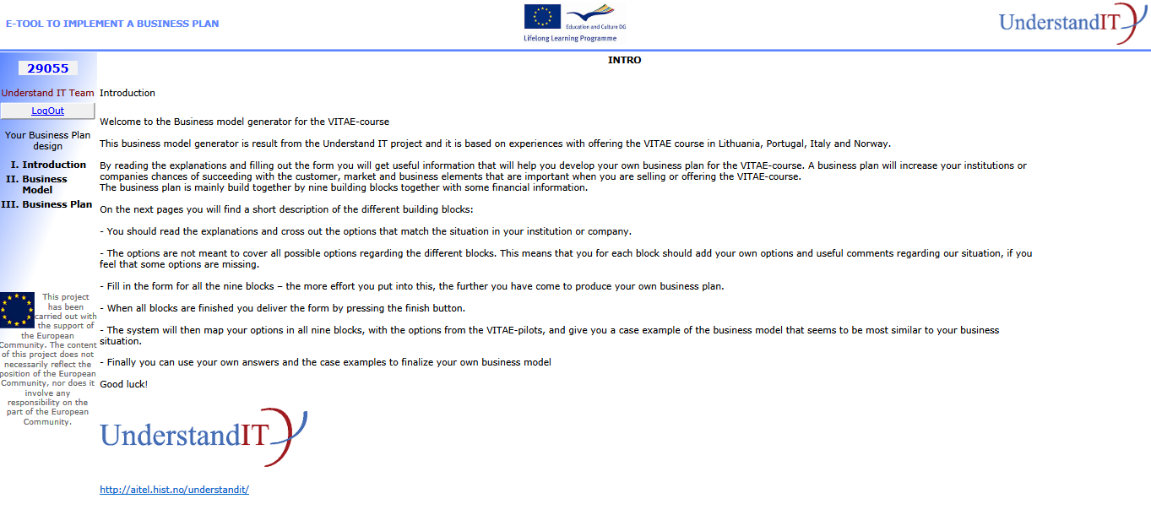

Business Model Pages
There’s one page for each block. On this pages the user chooses the options that best describe its business and inserts some free text notes, related to the block or explaining the options taken.
At any time the user can save the business model and logout. With the access code will return to it.
To complete a business model the user must have, at least, one option chosen for each block.
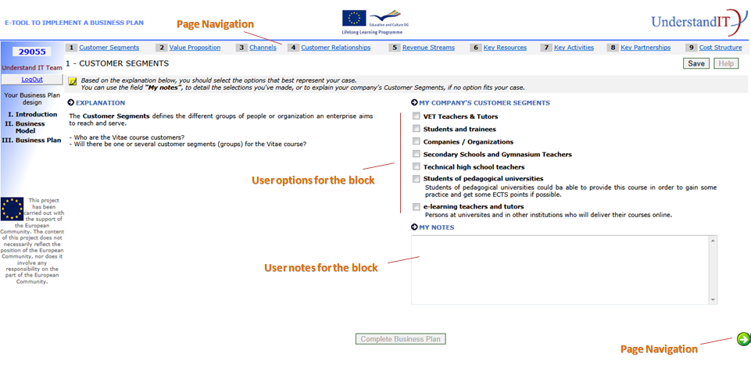

Result: Business model “book”
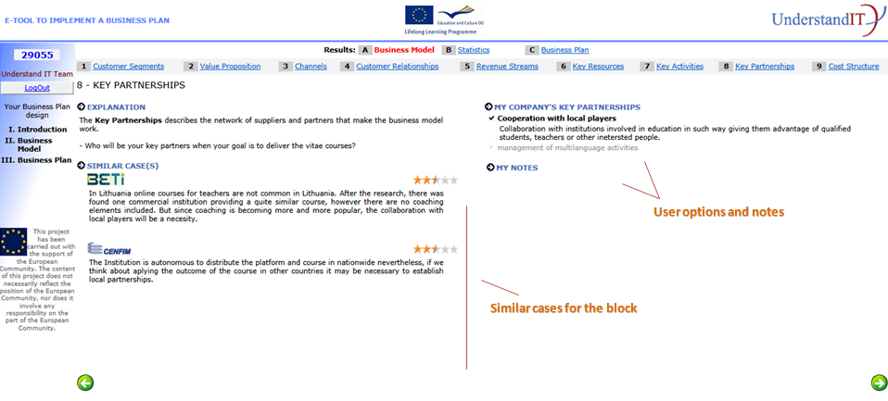

Result: Statistics
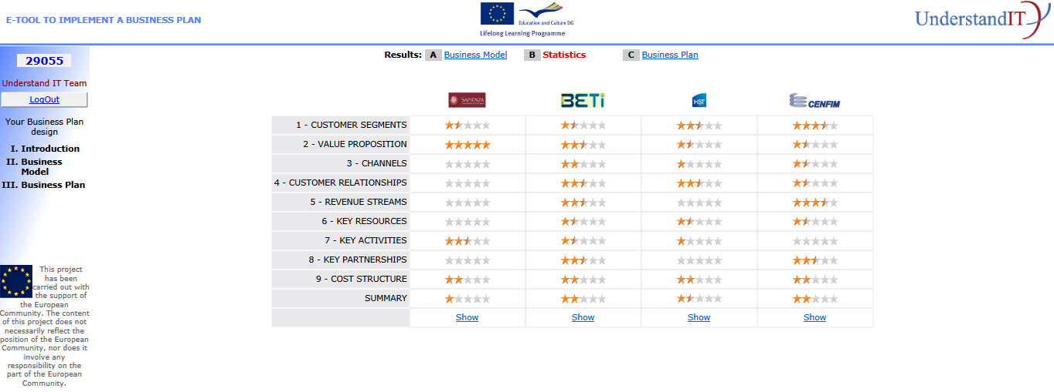

Using the “show” button the user can read the complete business model of each case study.
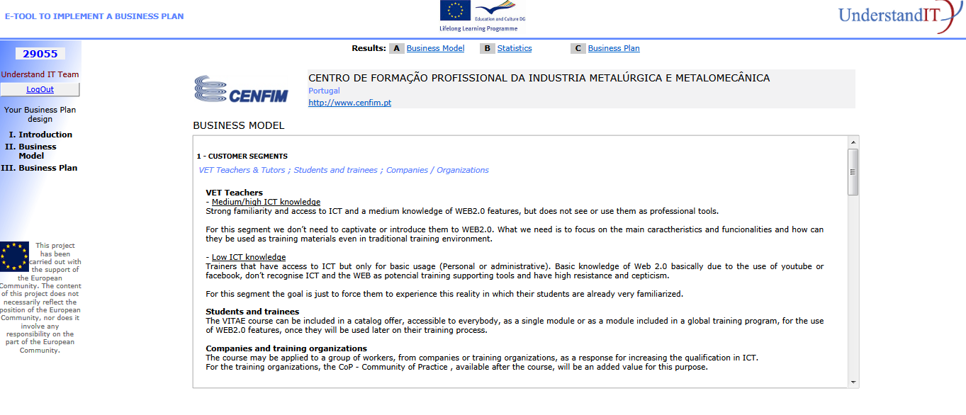

Result: Business plan guidelines
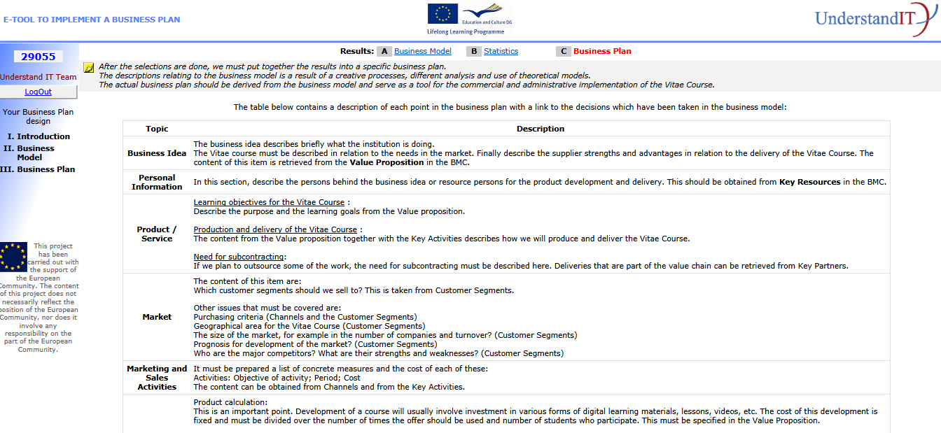

Back Office interface
The back office is just a friendly interface to be used by the partners to insert the required information:
- Introduction text
- Block’s title, subtitle and explanation
- Case study description for each block
- Options order, title and description for each block
- Association between block option and each case study (used in the similarity algorithm)
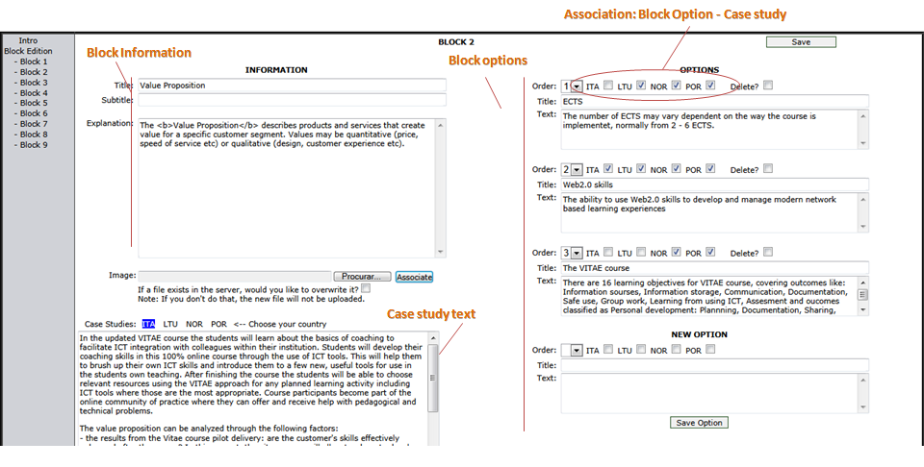

Similarity Algorithm
The degree of similarity is obtained by weighting the number of common options, between the user and the case studies, with the total number of options for each case study. It will be presented graphically through a set of 11 images, representing the rounded value of the result.

Example
Block options |  |  | Case studies |  |  |  |  | User options |  |  | Similar cases / Statistics
 |  |  | Country 1 | Country 2 | Country 3 | Country 4 |  | User 1 |  |  | Country 1 | Country 2 | Country 3 | Country 4
block 1 | option 1 |  | x |  | x
 | option 2 |  | x | x |  | x |  | x |  |  | x | x |  | x
 | option 3 |  | x | x | x | x |  | x |  |  | x | x | x | x
 | option 4 |  | x
 | option 5 |  |  | x
 | option 6 |  |  | x
 | option 7 |  |  |  | x
 | option 8 |  |  | x | x
 | option 9
 | option 10
 | option 11
 | Nº Options |  | 4 | 5 | 4 | 2 |  | 2 |  | Nº Options In common | 2 | 2 | 1 | 2
 |  |  |  |  |  |  |  |  |  | Nº Options in common / Country nº of options | 50% | 40% | 25% | 100%
 |  |  |  |  |  |  |  |  |  | Image | 5 | 4 | 3 | 10

0 |  | 1 |  | 2
3 |  | 4 |  | 5
6 |  | 7 |  | 8
9 |  | 10

Installation Package
The application is hosted on CENFIM’s web server. CENFIM guarantees the required maintenance to keep the tool running.
It will also be delivered a package with:
- The procedures for installing the database, with the case studies contents (Requires SQLExpress or SQL server, V2005 or higher);
- Site Web pages (.NET C # / Framework 1.1) – Requires IIS

Language adaptation
The tool is only in English, the official language of this project.

